**Intelligent Customer Help Desk with Smart Document Understanding**

**Team : Jayaram R**

**Email : www.jayaram.r.ramesh@?mail.com**

**Organisation : TheSmartBridge**

### **1. Project Scope, Schedule, Team & Deliverables**

**Project Summary**

A chatbot is created which has the capability to answer different sets of queries asked by the customers. Using the Watson Discovery Smart Document Understanding (SDU) feature, we will enhance the Discovery model so that queries will be better focused to only search the most relevant information found in a typical owner's manual.

BThe benefits of this kind of chatbot is that it is superior than the typical chatbot which can answers simple questions like store location and hours. The chatbot is upgraded with the help of watson discovery collection which is build using smart document understanding.

If the customer question is about the operation of a device, we will use the webhook feature of Watson Assistant to pass the question onto our Watson Discovery Service, which has been pre-loaded with the device’s owners manual.

**Project Requirements**

* IBM Cloud
* IBM Watson services
* Node Red
* Web Framework

**Functional Requirements**

* A Chatbot that will be able to answer queries asked by customers.
* Redirect the operational queries to Owner's manual.
* Redirect the query to the particular section of the owner's manual.

**Technical Requirements**

* Using Watson Assistant create a chatbot
* Using Watson Discovery to redirect the user's query to the section of the owner's manual.
* Using Node Red to wire together Api and online services.
* Integrating it with IBM Cloud.

**Software Requirements**

* Web browser
* IBM watson services
* IBM Assistant
* IBM cloud
* Github
* Node red

**Project Deliverables**

Projects create deliverables, which are simply the results of the project or the processes in the project. That means a deliverable can be something as big as the objective of the project itself or the reporting that is part of the larger project.

From this project, problem statement is aimed at a chatbot would be able to identify any operational question posted by the user and using IBM Watson discovery will redirect the user to the section of the owner's manual.

**Project Team**

By Jayaram R

**Project Schedule**

The project is scheduled for 4 weeks

**2. Setup The Development Environment**

**Github Account**

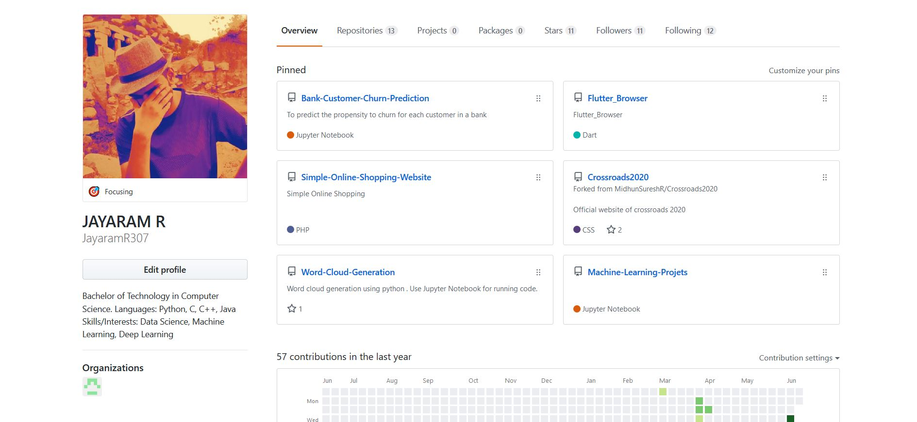

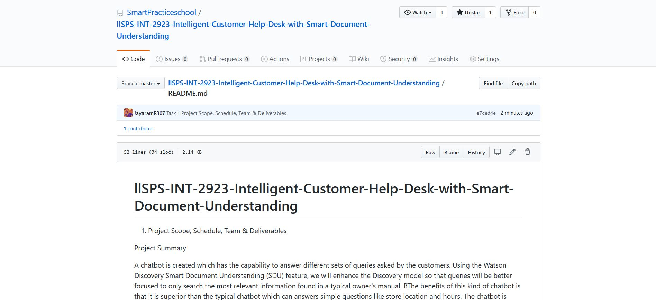

**Slack Account**

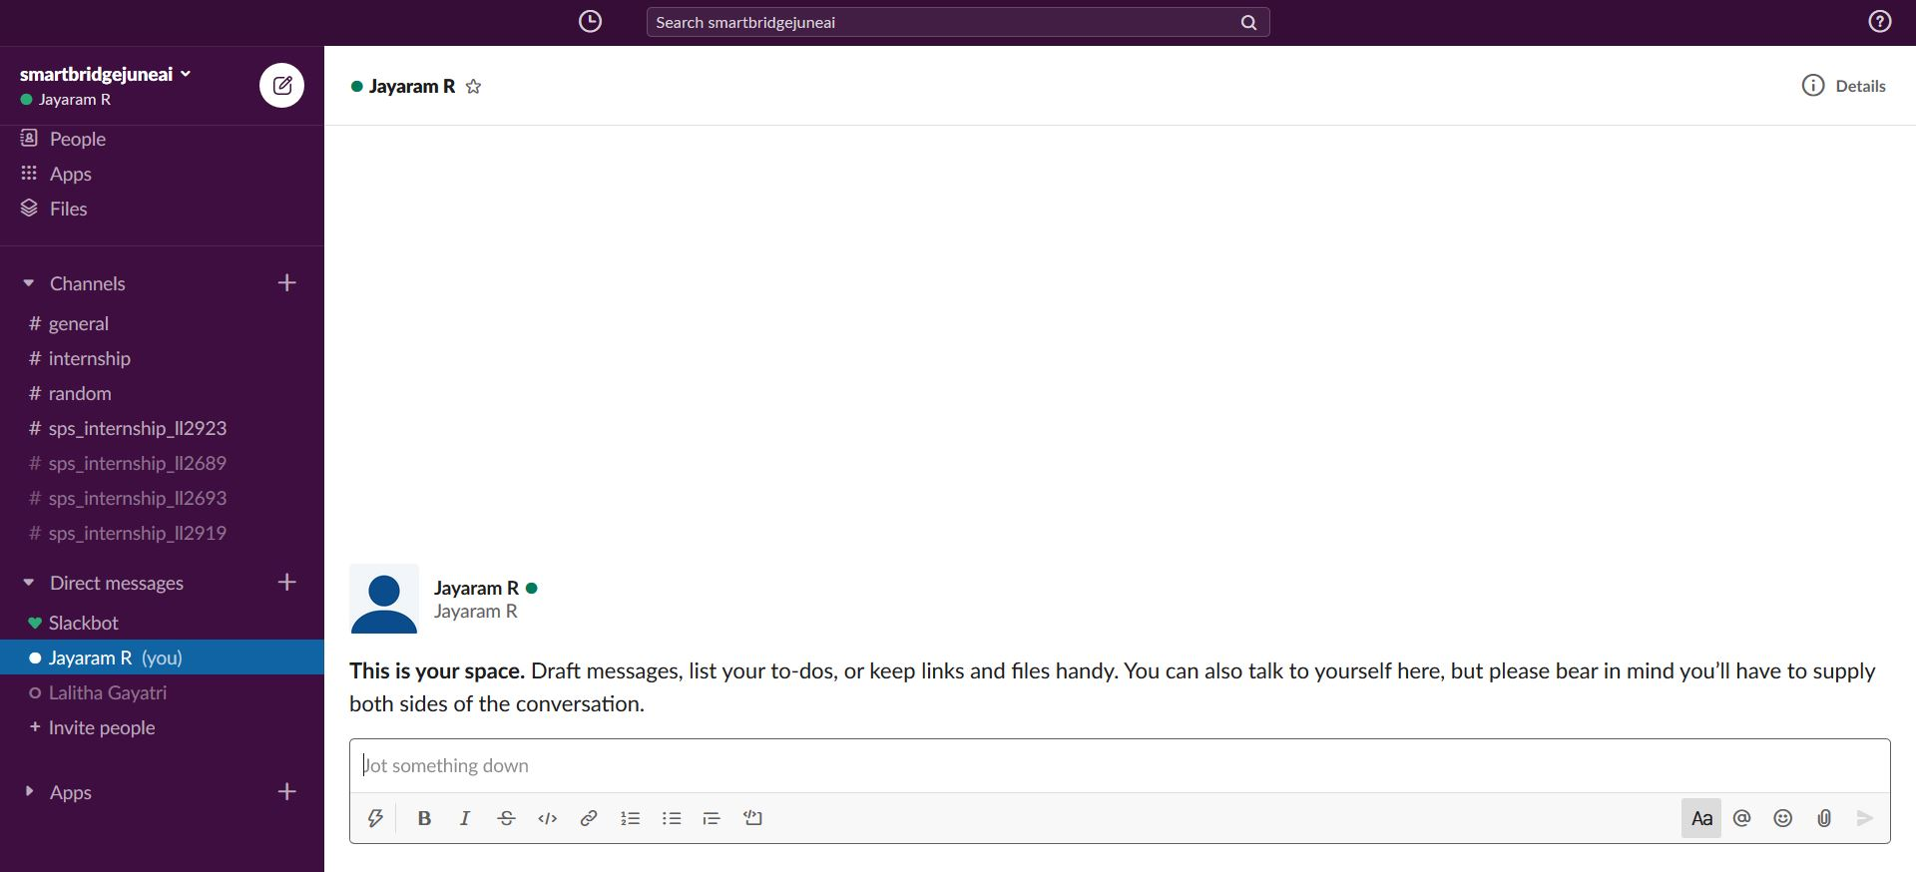**Zoho Writer**

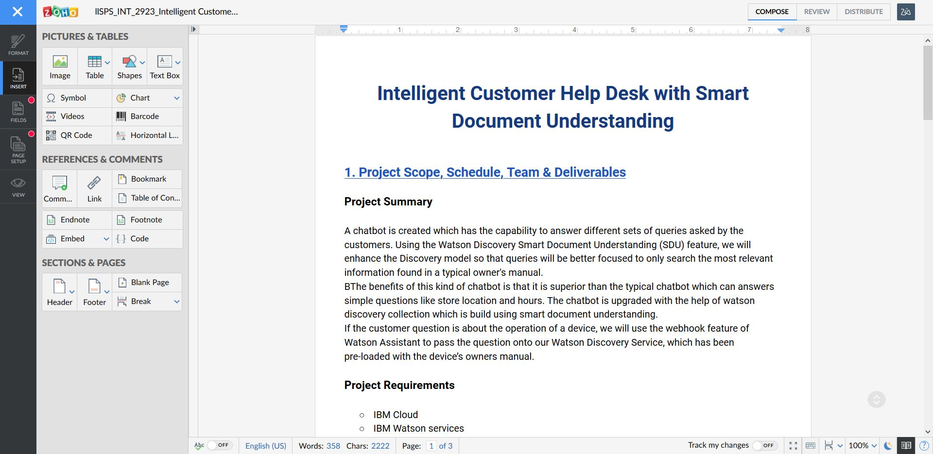

**IDE - Visual Studio Code**

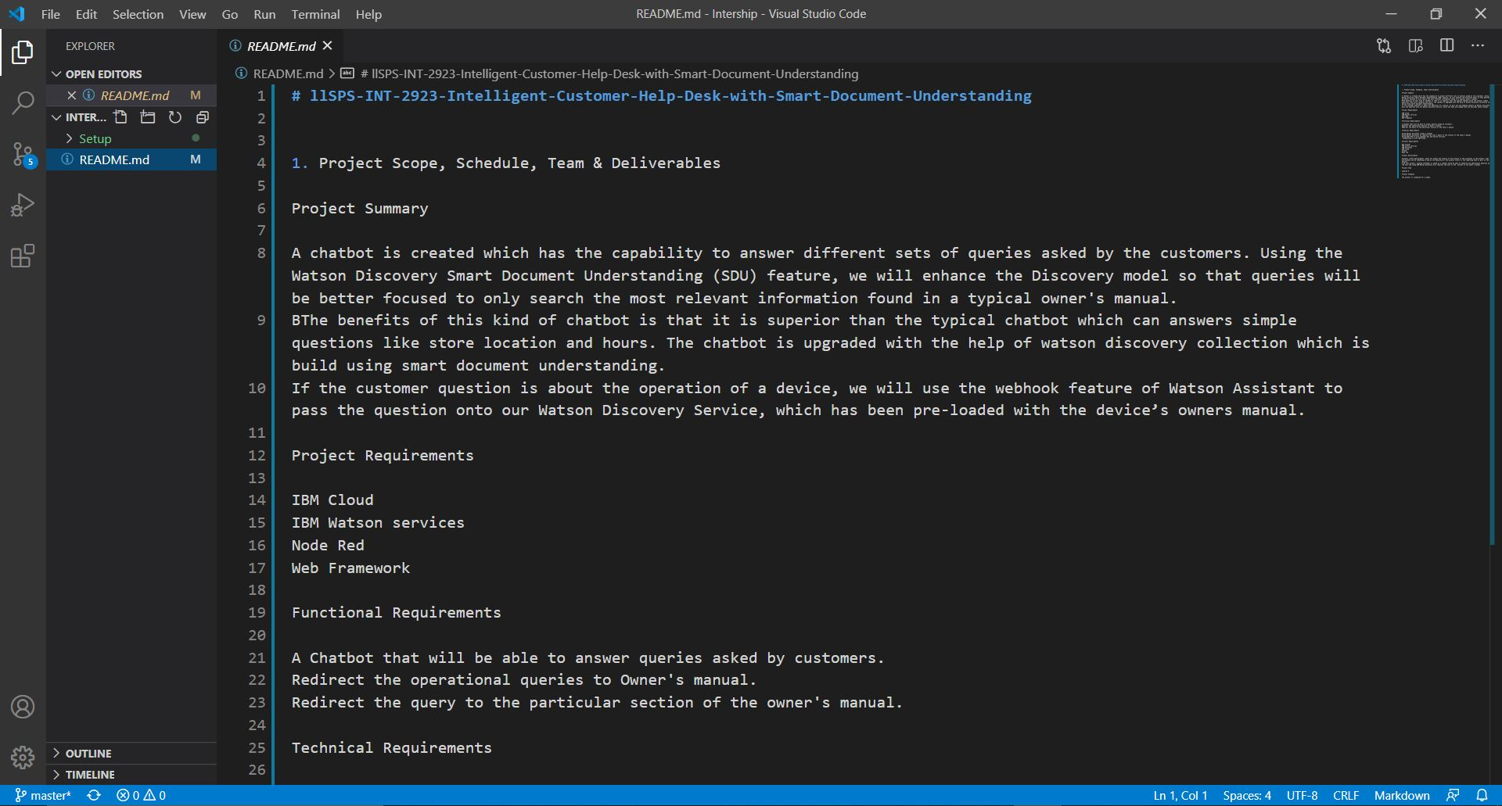

### 3. Create IBM Cloud Account

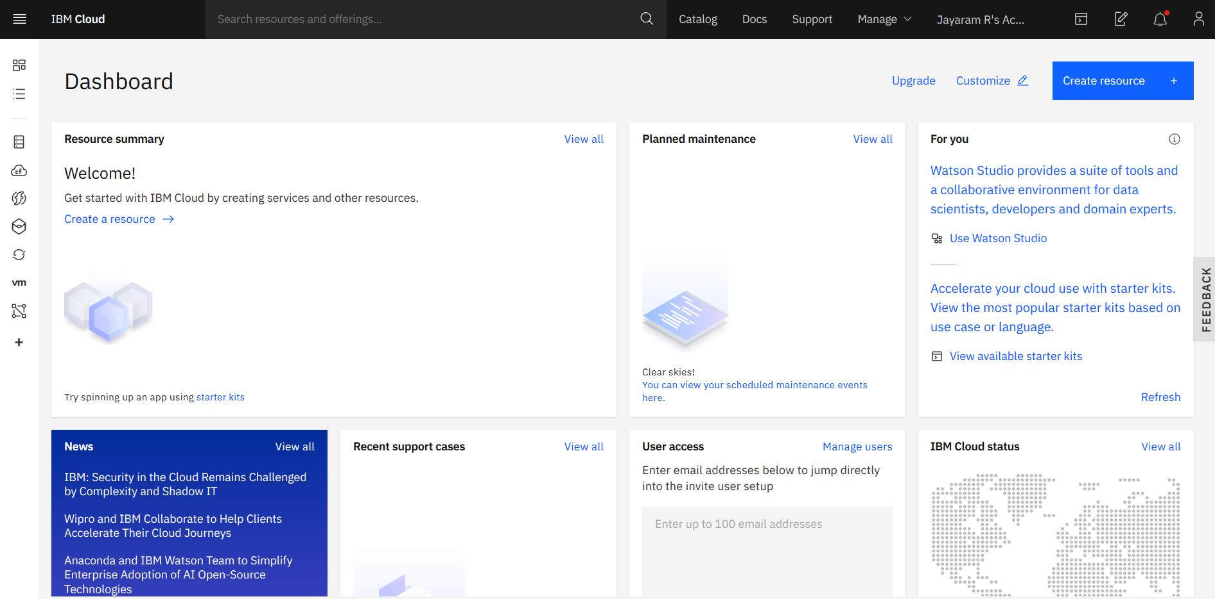

### 4. Create a Node-RED Starter Application

### Node-RED Starter Application

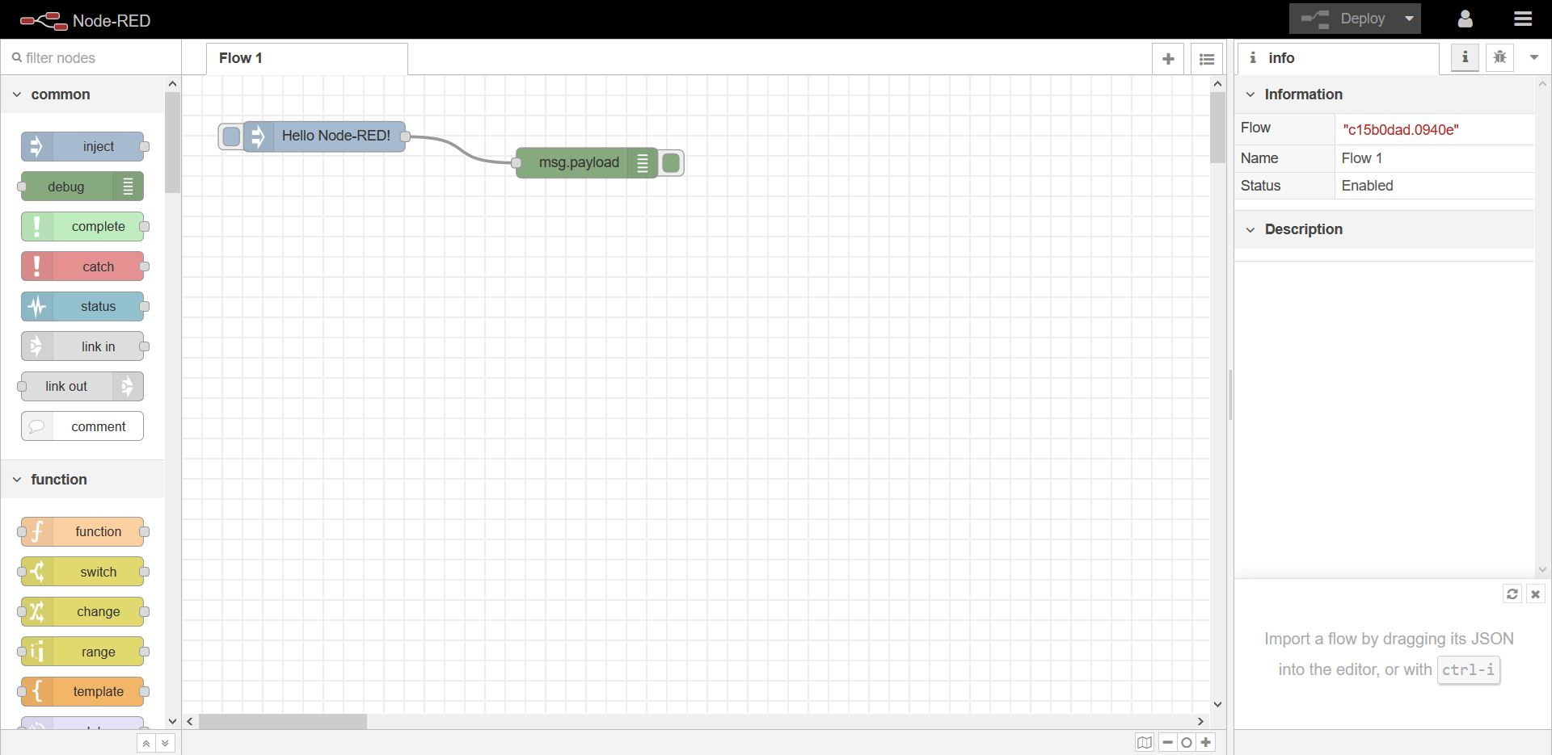

**Create A Simple Webpage**

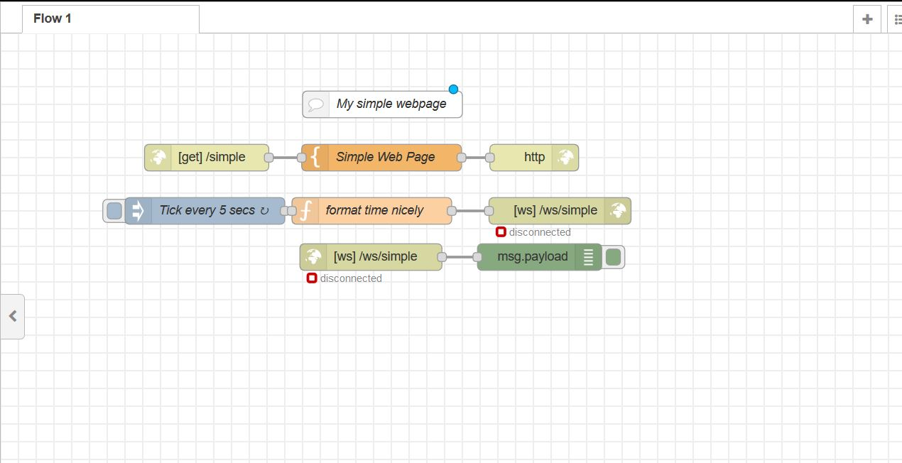

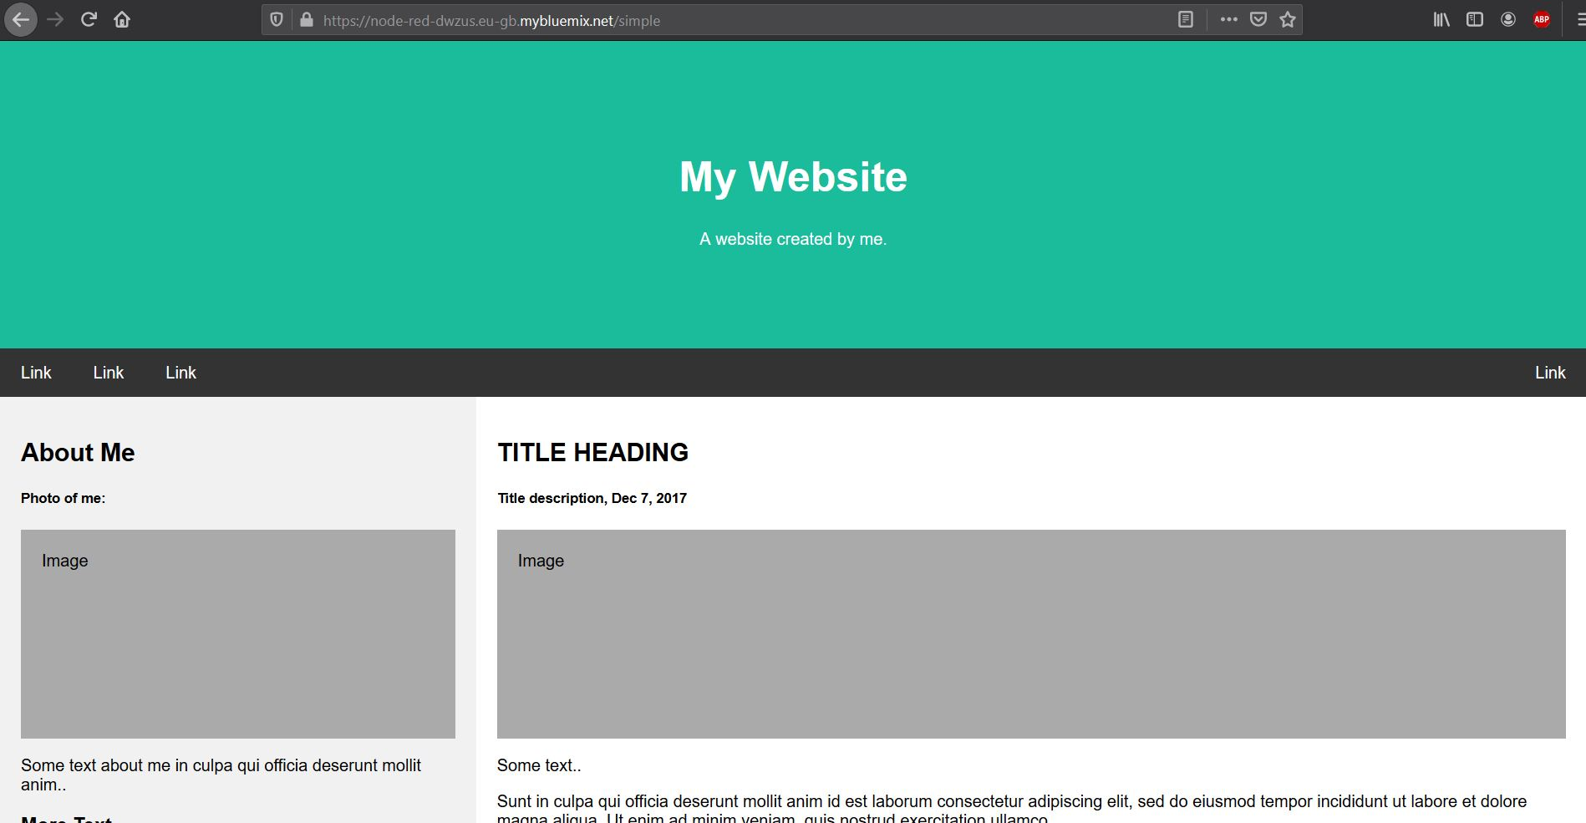

Webpage Link : <https://node-red-dwzus.eu-gb.mybluemix.net/simple>

### 5. Introduction to Watson Assistance

**Build Your Own AI Assistant (Chatbot) with IBM Watson Assistant**

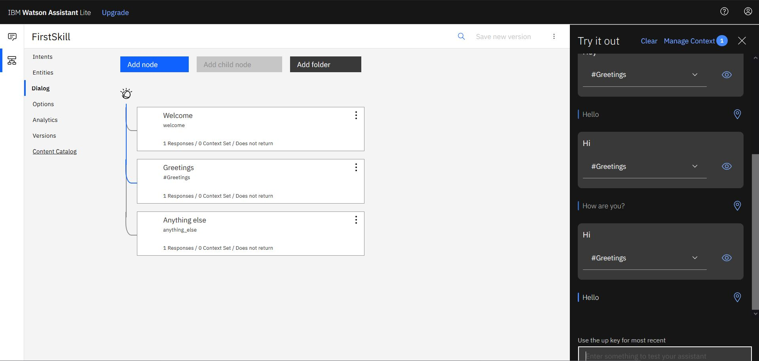

**IBM Cloud: How to Use Watson Assistant with Webhooks**

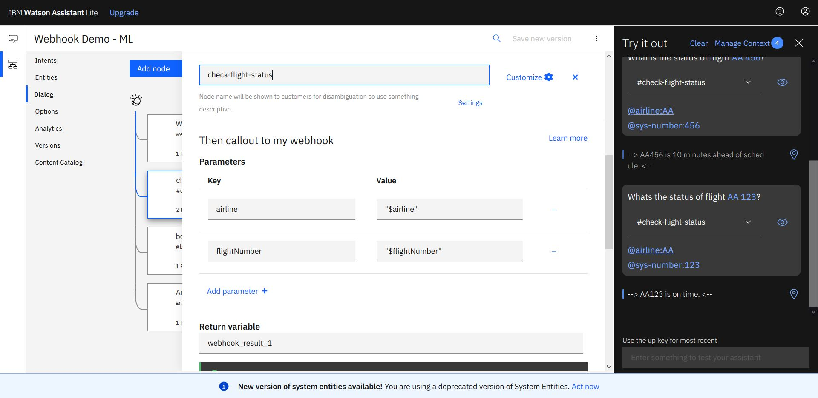

### 6. Introduction to Watson Discovery

**Extract Answers From Large Document in 5 Minutes**

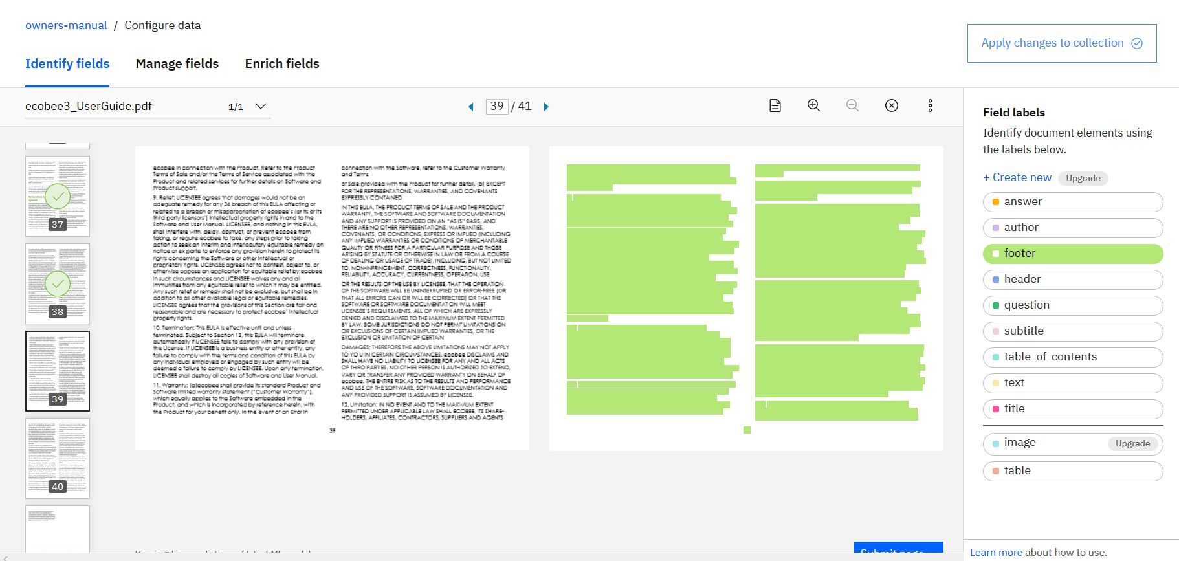

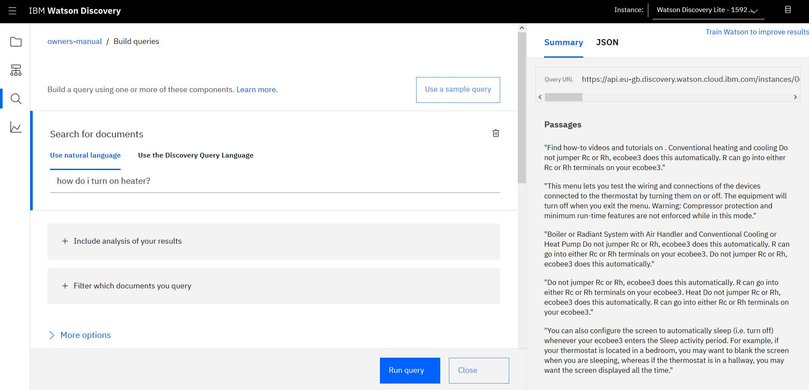

### 7. Getting Started with IBM Cloud Functions

**Getting Hands-on with IBM Cloud Functions**

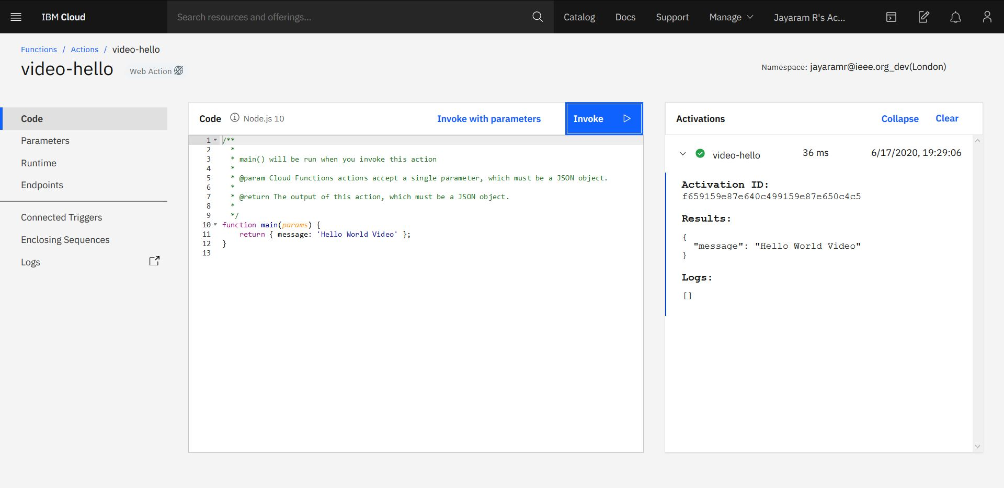

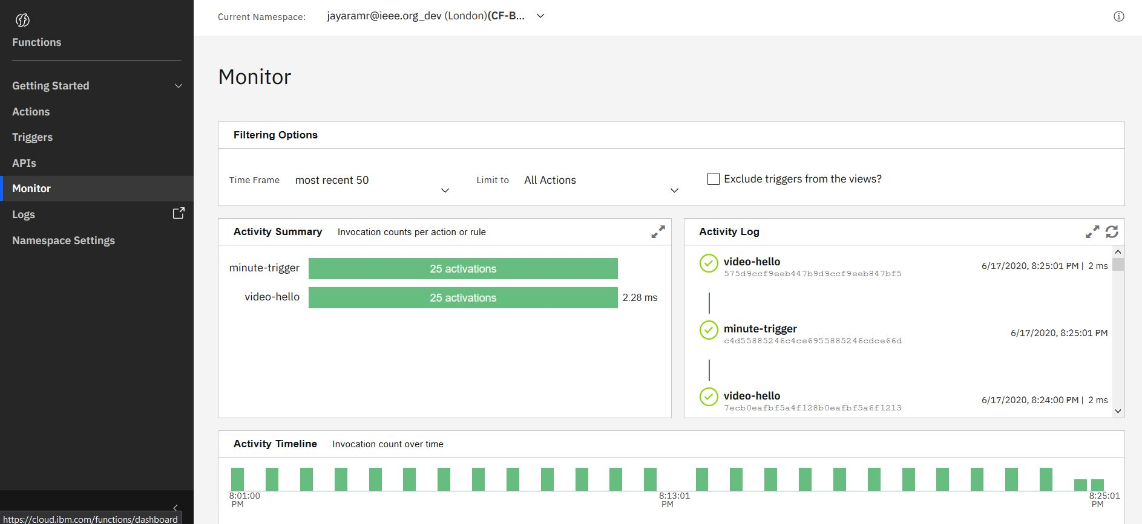

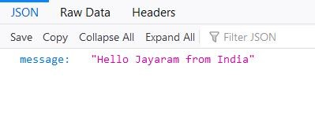

### 8. Create necessary IBM Cloud Services

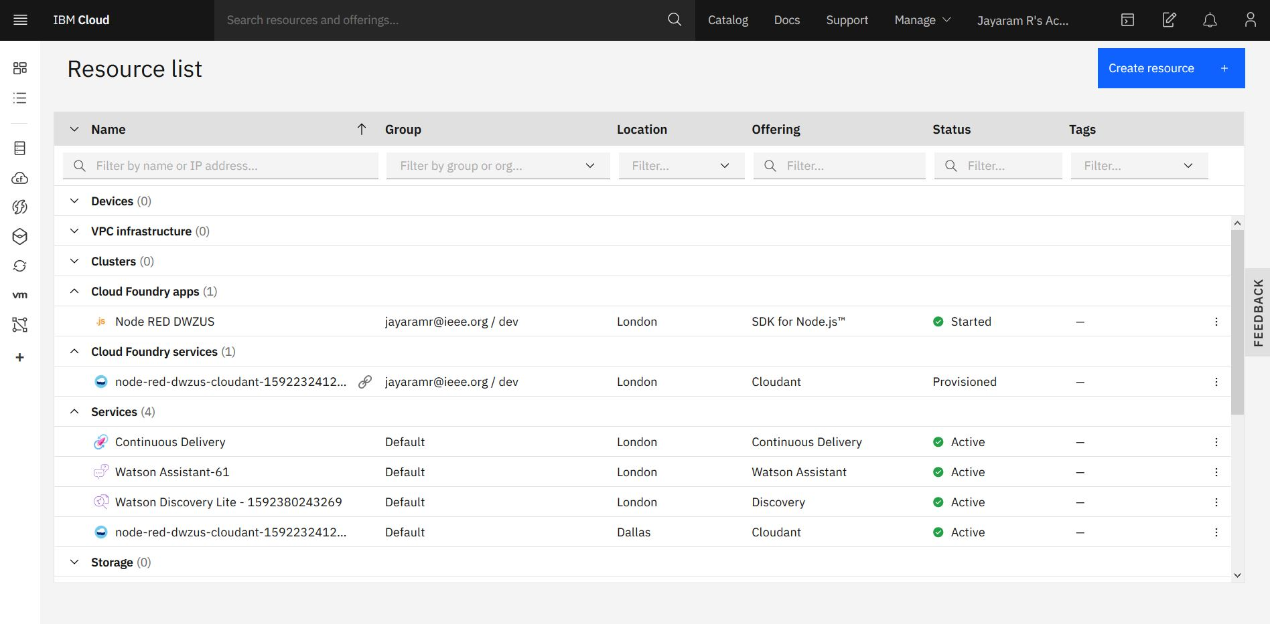

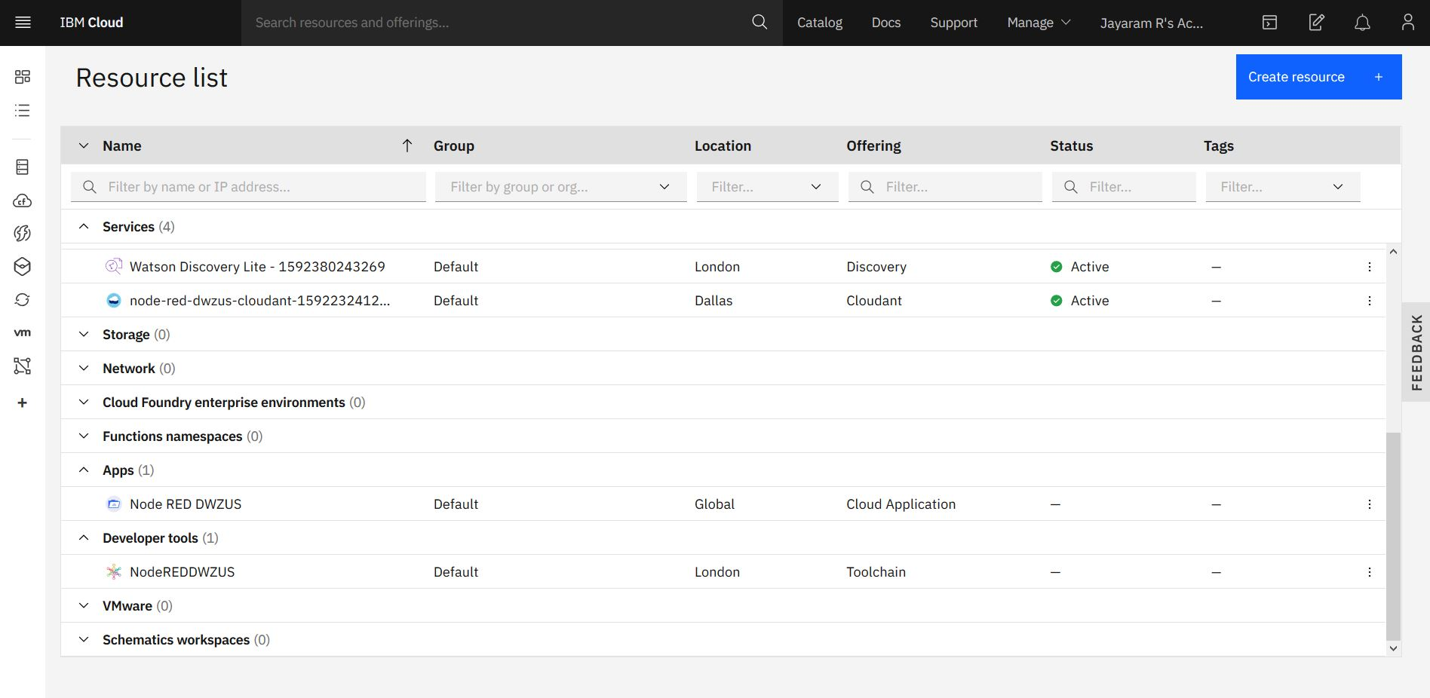

### 9. Configure Watson Discovery Service

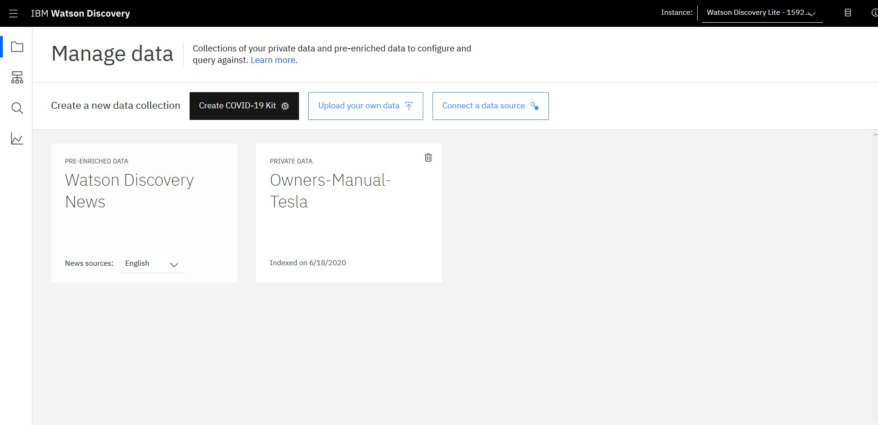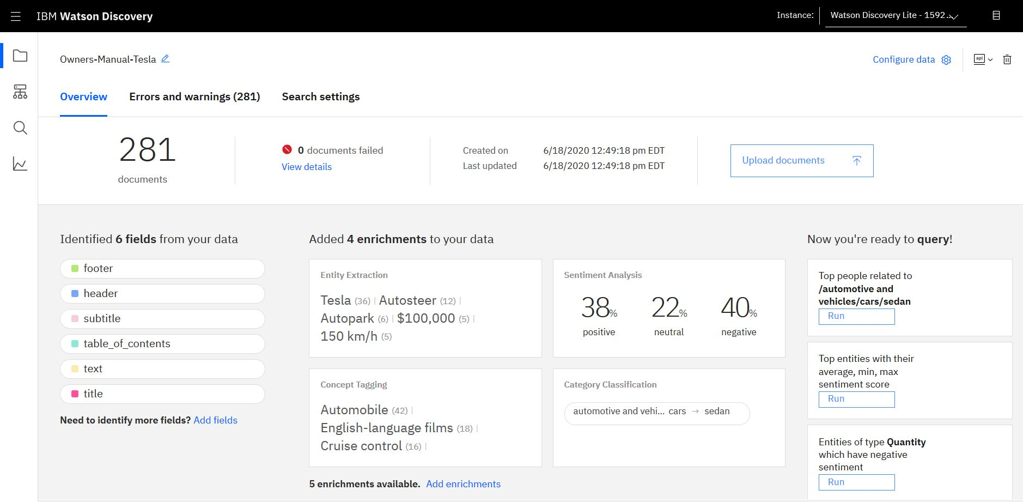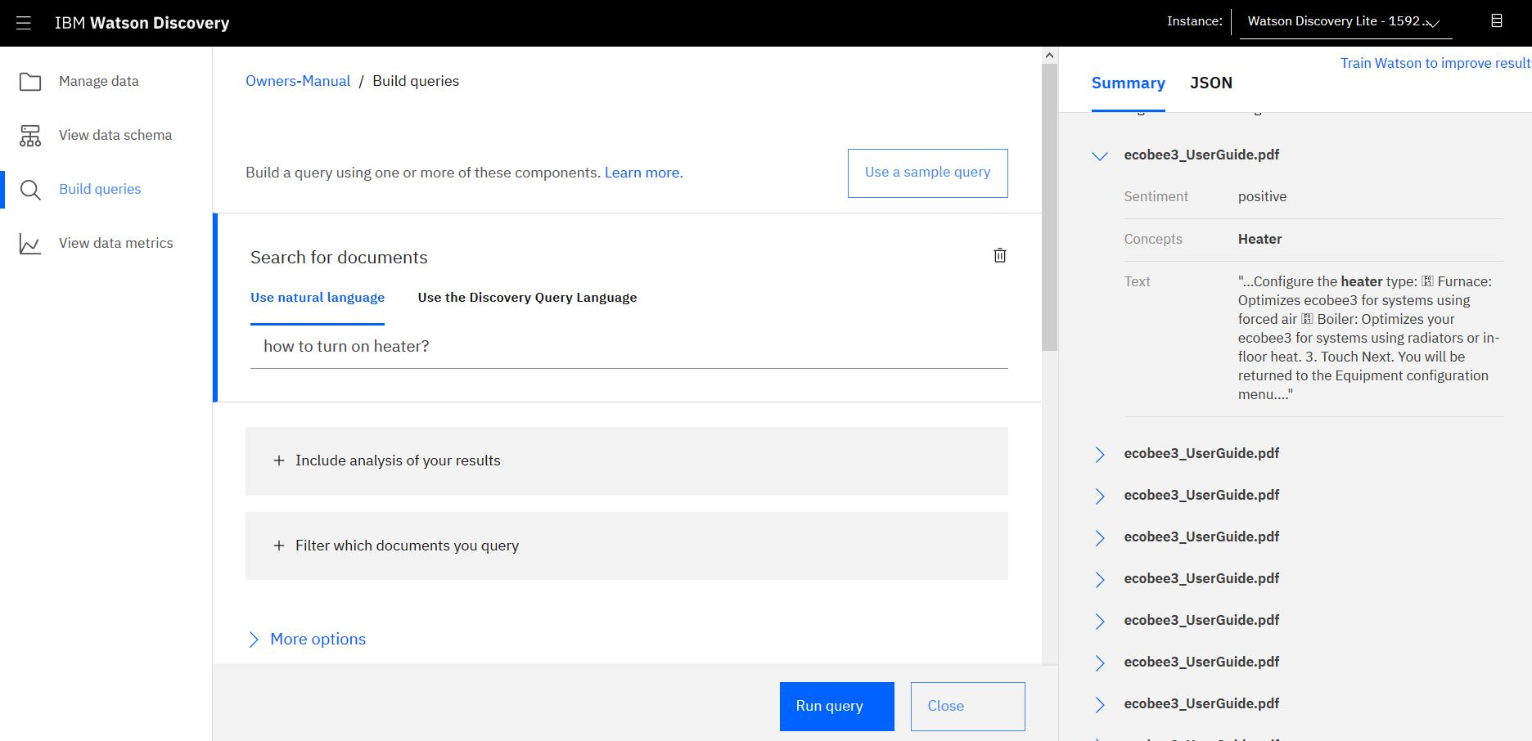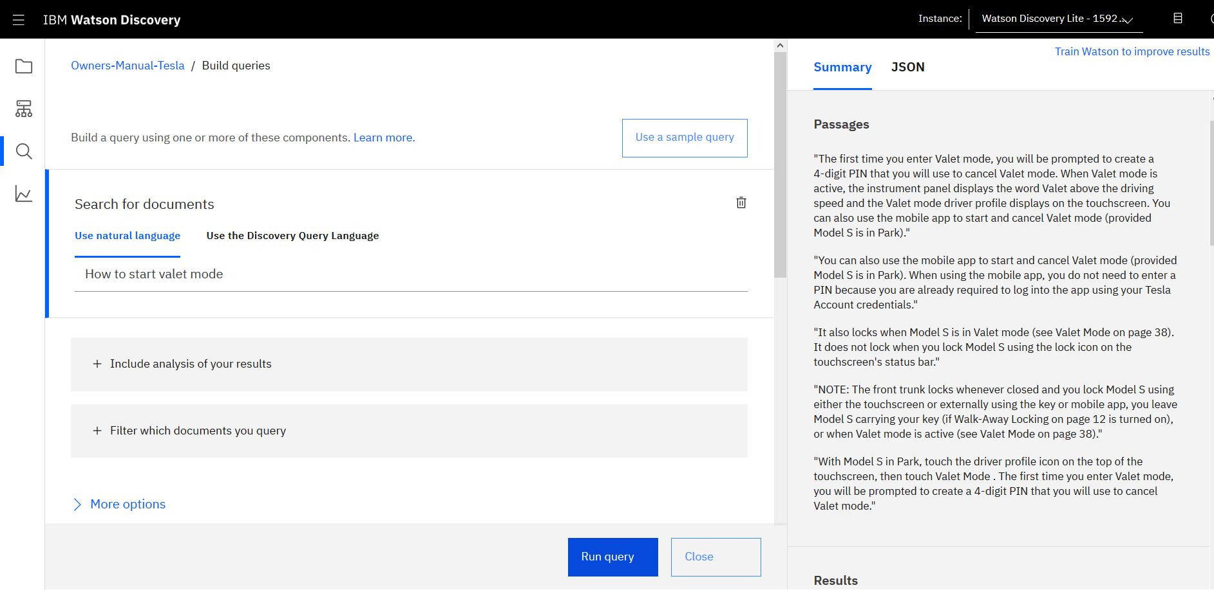

### 10. Create Cloud Functions Action

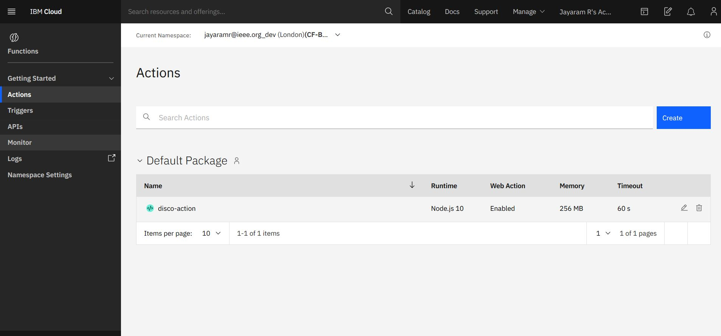

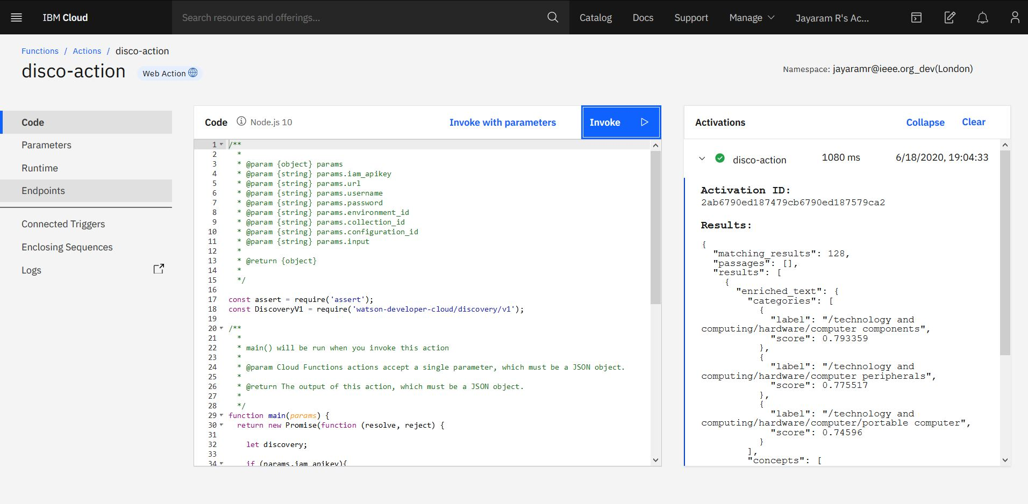

### 11. Configure Watson Assistant

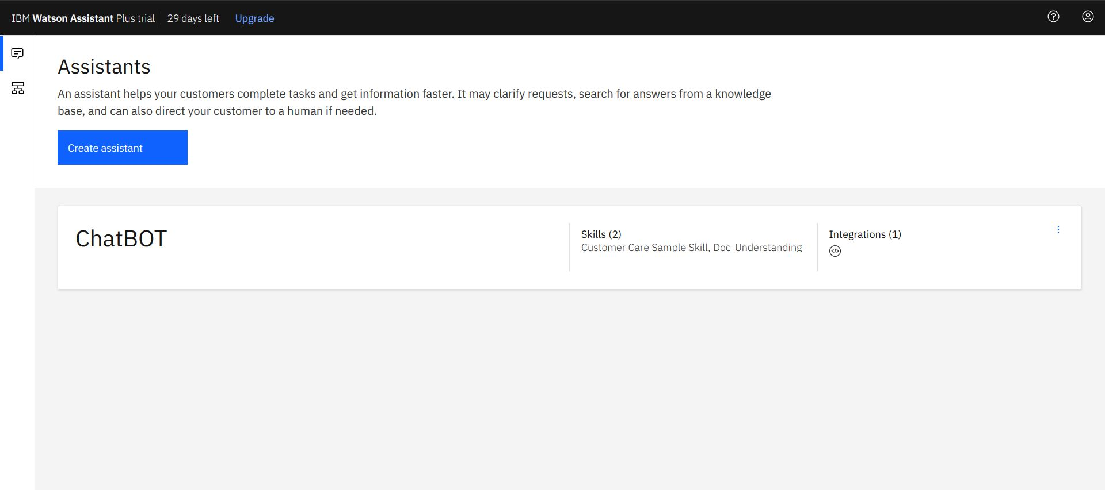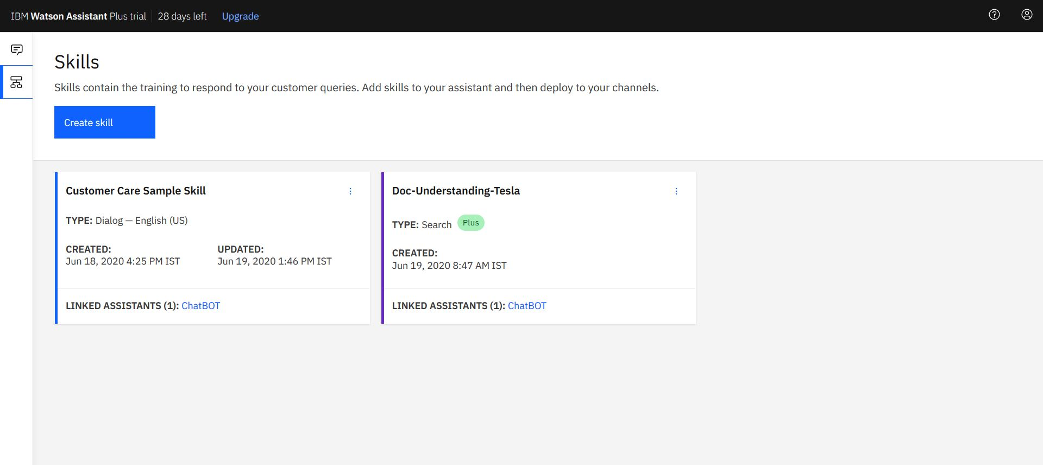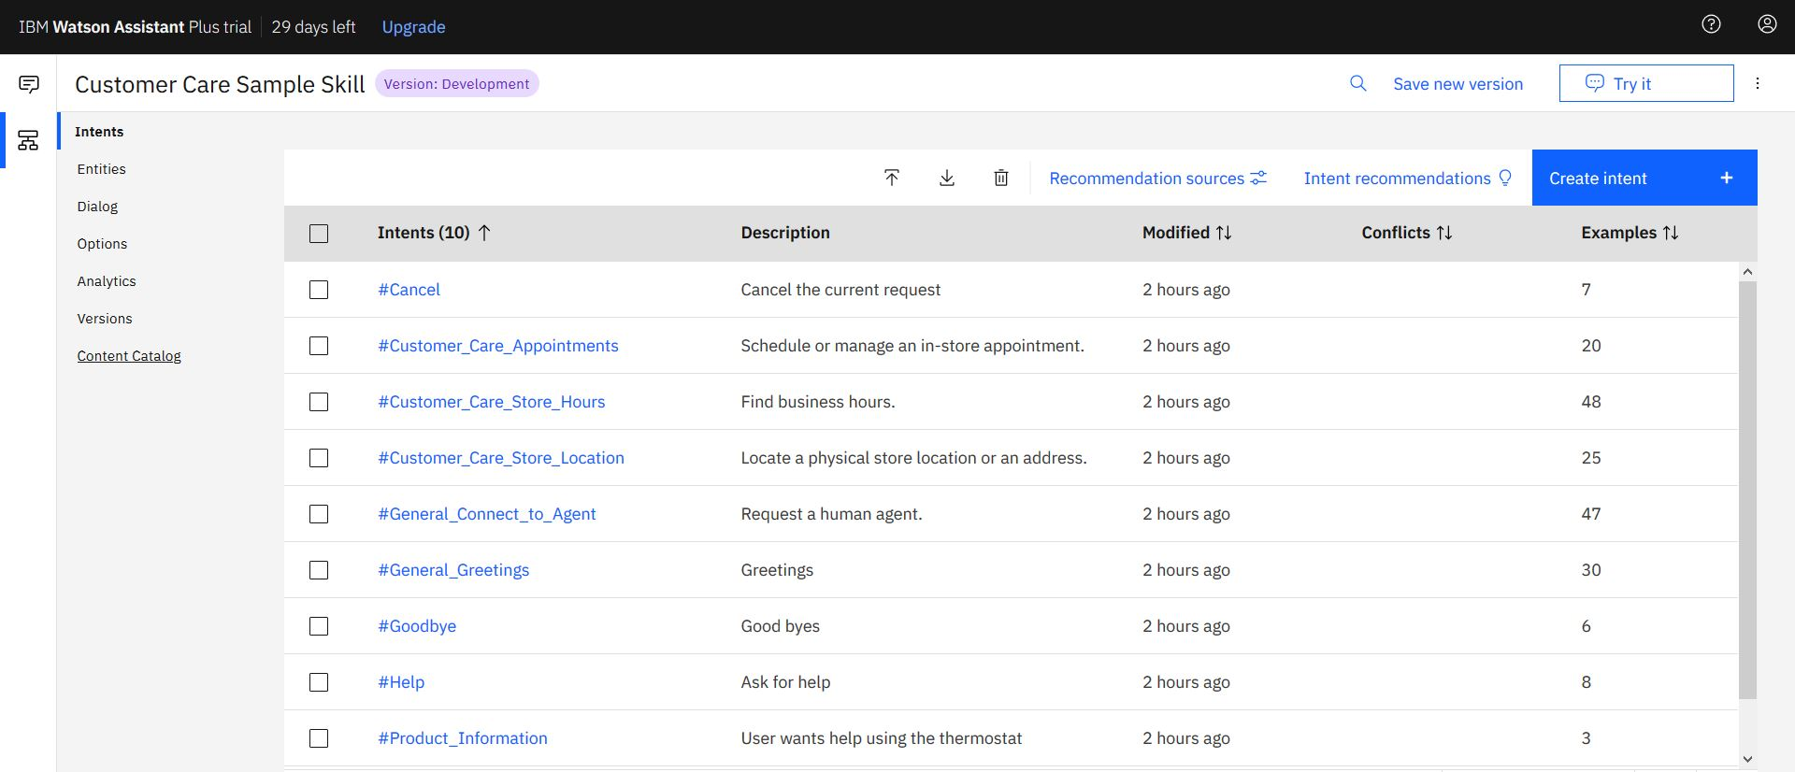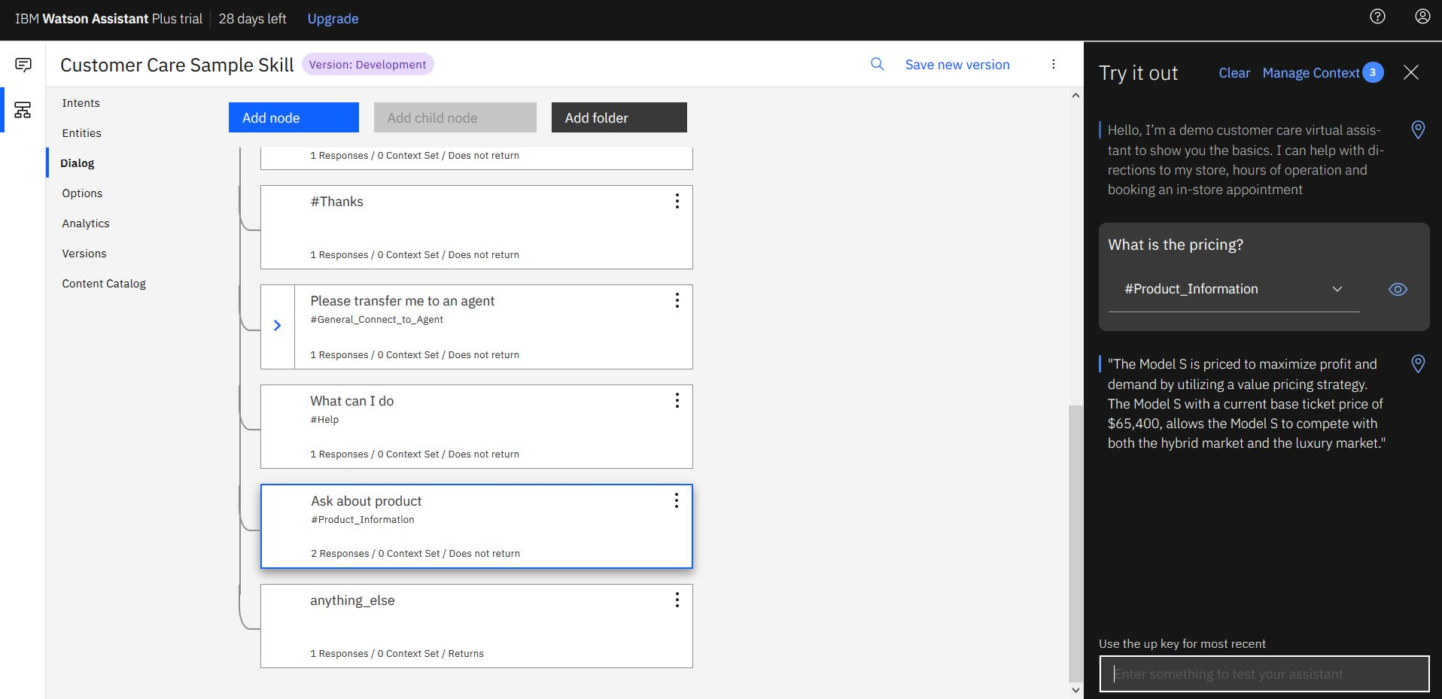

### 12. Build Node-RED Flow to Integrate All Services13. Build a Web Dashboard

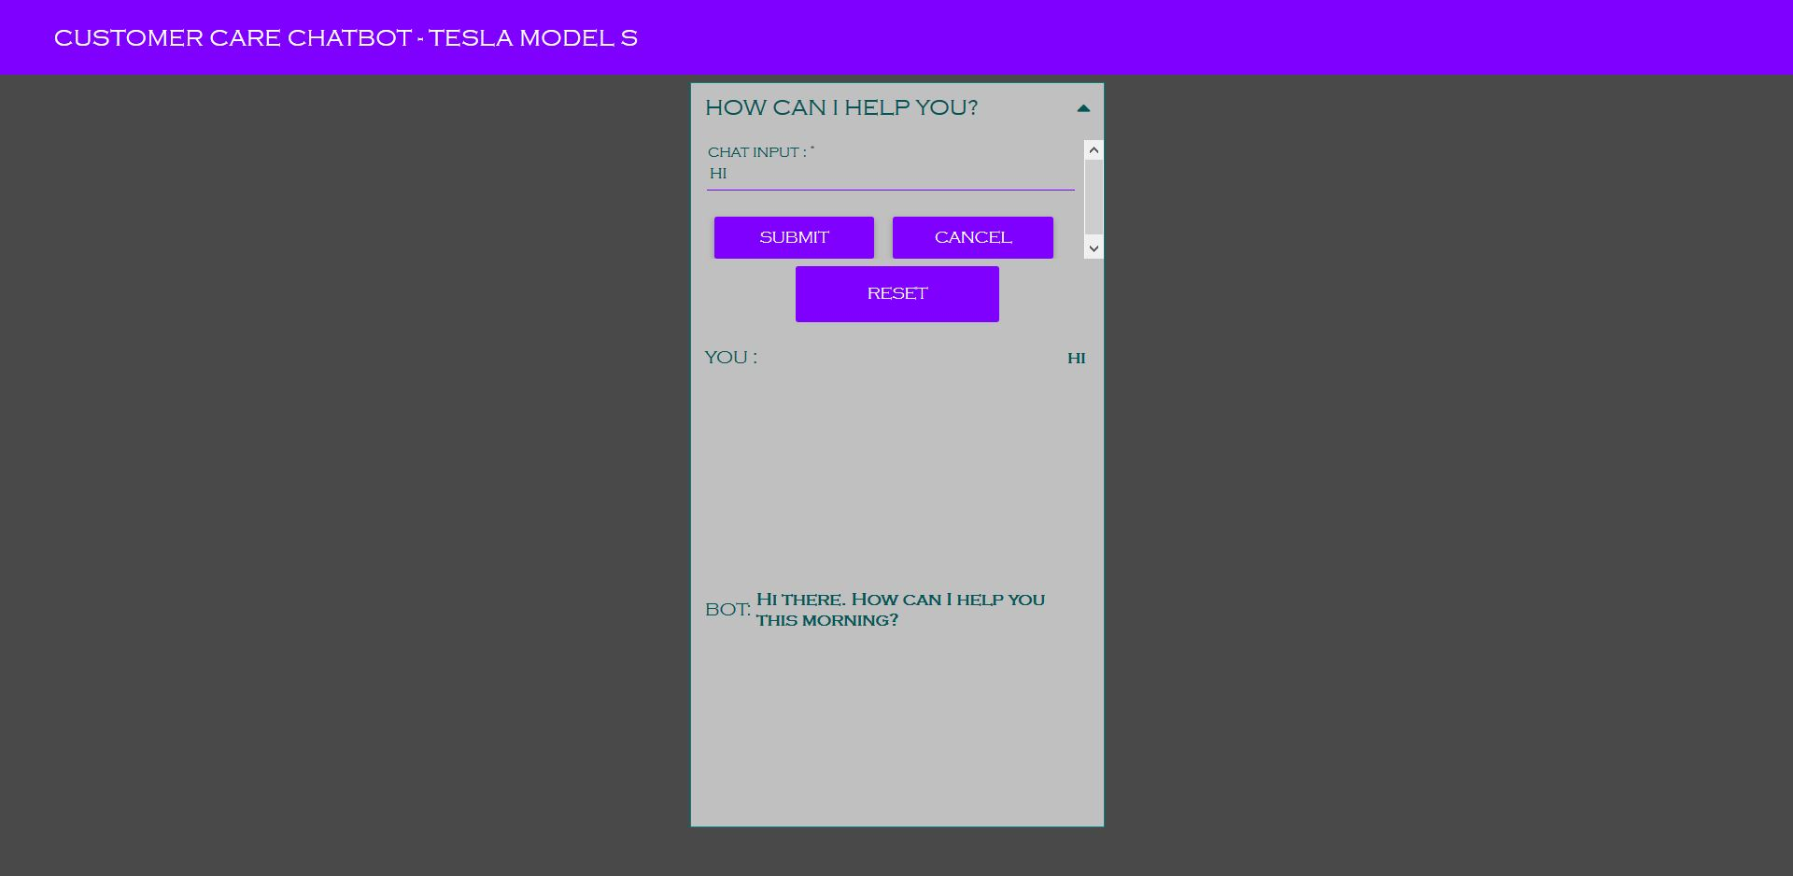

### 14. Test the Bot & Capture the Results

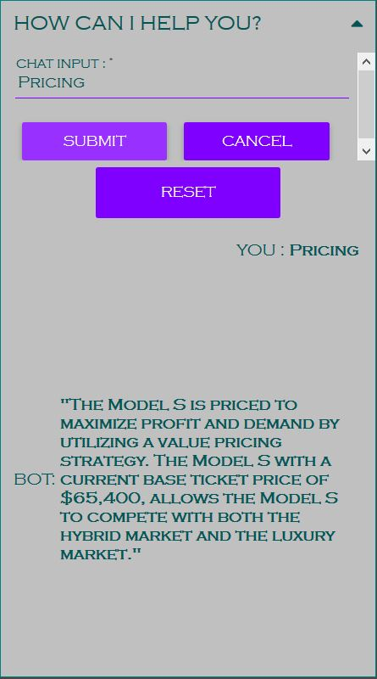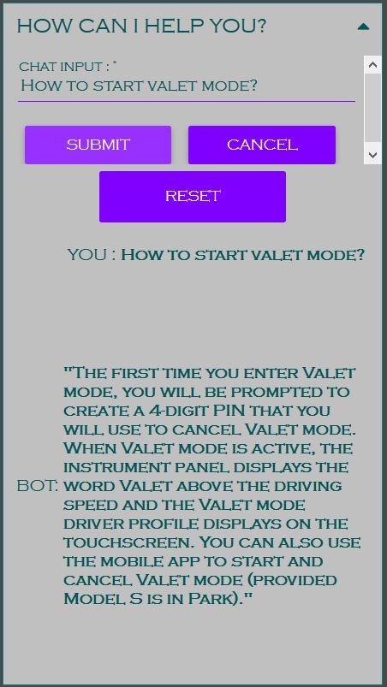

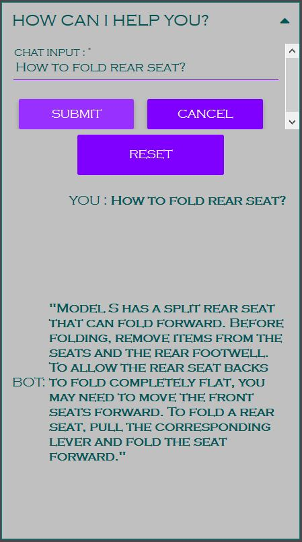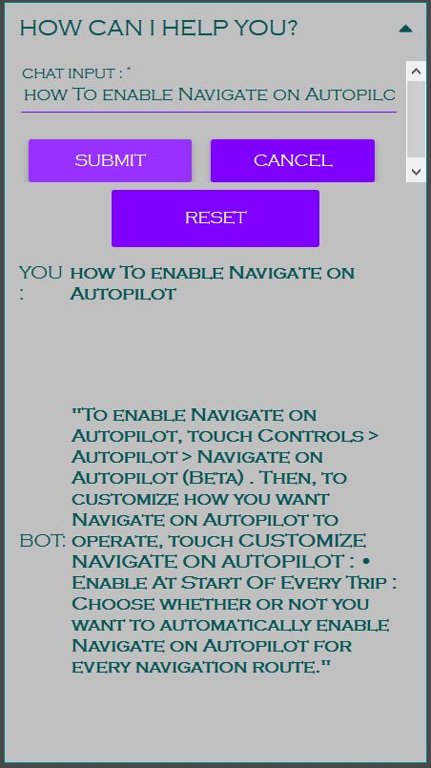

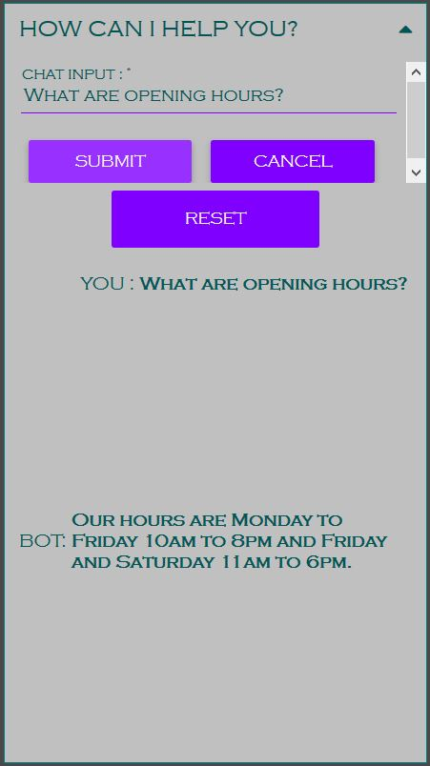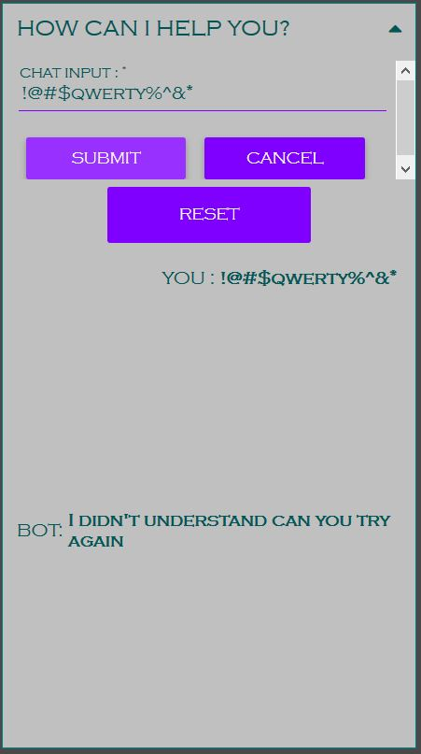

### 15. Prepare the Project Report & Upload the Node-RED Flow to GitHub

